# **This article title (rules of preparation of abstracts)**

## Author A.B.1, Author С.D.2, Author E.F.3

### 1Affiliation one, Zip, City, Country

### 2Affiliation two, Zip, City, Country

### 3Affiliation three, Zip, City, Country

Abstracts should be written in English. The size of the Abstract should fit to one or two pages exactly including the illustrations and tables. Please type your text by using the following parameters:

* page size: A4;
* margins (top, bottom, right and left): 1 inch (25.4 mm);
* font: Times New Roman; font size: 12 pt;
* line spacing: 1.15 line.

The title should begin the abstract (bold font, 1.5 line spacing). Next line – author(s) name(s) (1.5 line spacing) and affiliation(s) (1.0 line spacing). The presenting author's name should be underlined. The next line should be blank. The text should be placed after this line.

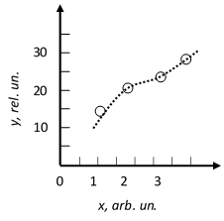

Fig. 1. Example for figures

Figures with captions and tables can be included into text. Description to the graph should not be very small and the lines do not have to be very thin. Allowed to flow around the graph by text. Preferable to use graphics in vector format [1] (vector graphics not bitmap).

The number of characters should be 2200 per page for plain text Abstract.

**References**

[1] N.P. Author1, Phys. Rev. A 70, 013603 (2004).

[2] N.P. Author1 and N.P. Author2, e-print arXiv:0704.3011 (2005).

[3] N.P. Author1, N.P. Author2, and N.P. Author3, Phys. Rev. A 70, 013603 (2004).

[4] N.P. Author1 and N.P. Author2, Book Title (Publisher, City, 2007).